**Team Members:**

Roshini Varada- 26

V H N V R S Sai Pavan -27

**Source_commands**

**1.** aws --version

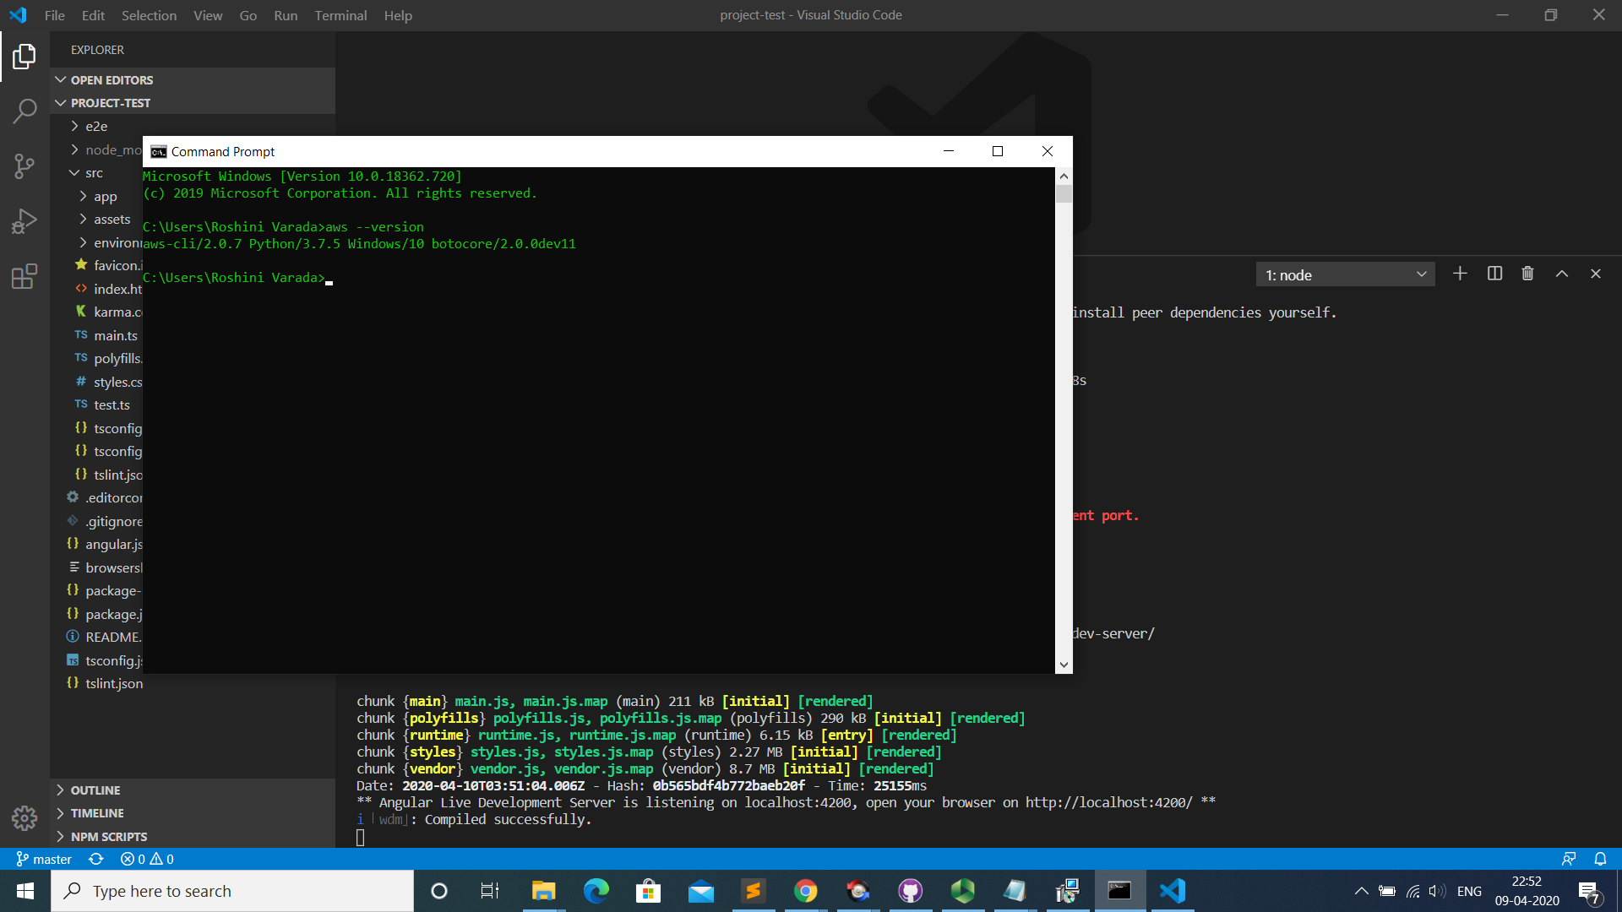

2. aws configure profile –profilename

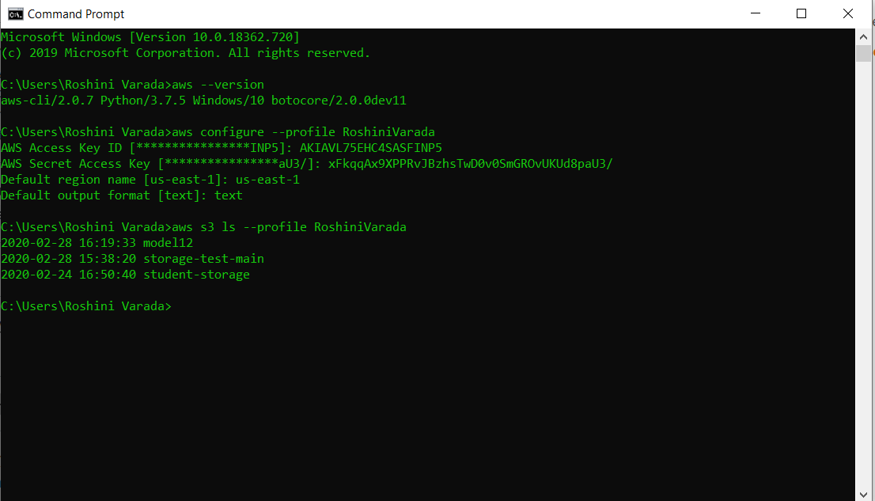

3.aws s3 ls –profile profilename to see the details of s3 storage

